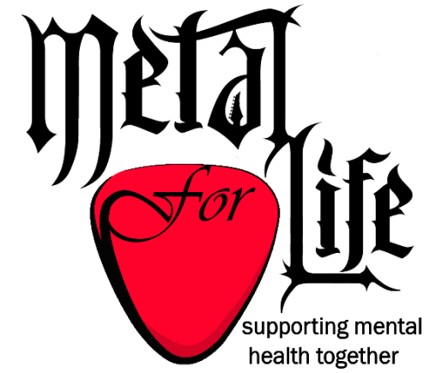
Metal for Life NI
Membership &
Registration for Support Groups

Thank you for showing interest in the Metal for Life NI support groups and services. Before you may become a member you must complete this form.

Membership entitles you to
  - attend Metal for Life NI Annual General Meetings
  - nominate and vote for Trustees to manage the Charity
  - be nominated yourself by another member to become a Trustee, should you so wish.
  - apply for Metal for Life NI voluntary roles (fund-raising, facilitation etc)
  - use Metal for Life NI services, such as peer support groups

Membership of Metal for Life NI is free of charge and continuous. However, the Metal for Life NI Board of Trustees may remove membership if they believe it is in the best interests of the charity.

By completing the registration form below, you confirm that you:
  - are over 18 years old
  - live in Northern Ireland
  - support the aims of Metal for Life NI and have an interest in its services and activities
  - agree to maintain confidentiality and respect for other members of Metal for Life NI

We will use your contact information to:
- invite you to Metal for Life NI Annual General Meetings

In addition, if you wish to attend Metal for Life NI Peer Support Groups, we will use your contact information to:
- decide how many support groups to offer and their location
- remind you to attend support groups
- contact you if we have to change the location or time suddenly
- contact you for feedback on content or operation of the support groups
- compile demographics for future application for funding of the Metal for Life NI charity

Name
Postcode
Age
Phone
E-mail (optional)
Preferred contact method
(e.g. messenger, whatsapp, e-mail, text)
I wish to attend Metal for Life NI Peer Support Groups (Yes / No)
Please e-mail your completed form to info@metalforlifeni.co.uk
Your details will be handled confidentially and held securely by the Metal for Life NI Board of Trustees and will not be forwarded to any other parties. You are entitled to withdraw membership and ask us to remove your information from our records at any time. Please do not hesitate to contact us if you have any concerns about the handling of your details.

